**STEPS TO DO :**

1. Go through the data description link.

*https://competitions.codalab.org/competitions/11161#learn_the_details-data2*

To understand what each term in the data means.

1. Check “ Data Pre Processing “ file from github link. To understand the data distribution.
2. Go through the following papers for features : Feature extraction being done by taking these as references :
3. <https://arxiv.org/pdf/1708.04479.pdf>  : first prize winners. Major reference.
4. <http://joaopalotti.com/wp-content/uploads/2016/11/cikmcup_palotti.pdf>
5. <http://delivery.acm.org/10.1145/3090000/3080838/p475-karmaker-santu.pdf?ip=165.91.48.36&id=3080838&acc=ACTIVE%20SERVICE&key=B63ACEF81C6334F5%2E79B51EFA2DE92FE8%2E4D4702B0C3E38B35%2E4D4702B0C3E38B35&__acm__=1555287855_d139d3cc02cd6752298a04cc6162b819>
6. Based on one of these papers, initial step of relevance would be manually generate these relevance factors.

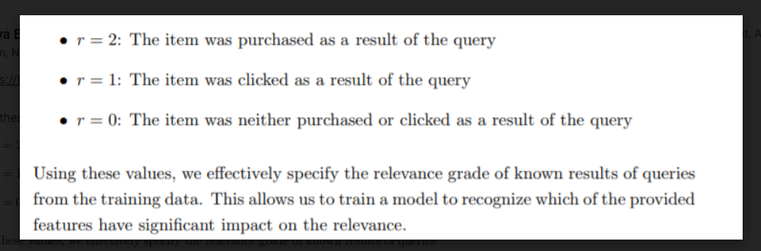

1. Given query and product get its corresponding features and the relevance labels defined in (4) and train a simple Feed forward Neural Network.
2. In parallel with (5), more features will be experimented on, Pairwise neural network will be experimented, Graph embedding will be studied and tried.

**INITIAL TASK SPLIT UP:**

1. DATA ANALYSIS AND FEATURE EXTRACTION : Srividhya and Ashwin
2. Given features and relevance labels, build , figure out and train a Feed forward Neural Network model : Abindu and Rishabh.